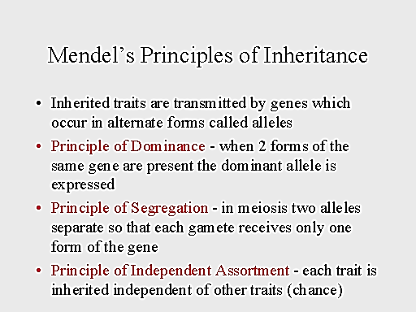
Mendelian and Human Genetics

Introduction
Gregor Mendel was a priest who worked in a monastery. He was responsible for maintaining the garden. As he bred pea plants, he noted important patterns about how the traits of the plant (he called them factors) were passed down. Mendel came up with important principles (to the right) to sum up his findings

Genetics is a complex field with lots of details to keep straight. But when you get a handle on some key terms and concepts, including the structure of DNA and the laws of inheritance, you can start putting the pieces together for a better understanding of genetics.

The Scientific Language of Genetics
From chromosomes to DNA to dominant and recessive alleles, learning the language of genetics is equivalent to learning the subject itself. The following key terms are guaranteed to appear frequently in your study of all things genetic:
- Alleles: Alternative forms of a gene
- Autosomal chromosome: A nonsex chromosome
- Chromosome: A linear or circular strand composed of DNA that contains genes
- Diploid: An organism with two copies of each chromosome
- DNA: Deoxyribonucleic acid; the molecule that carries genetic information
- Dominant: A phenotype or allele that completely masks the presence of the other, recessive allele in the heterozygote
- Gene: The fundamental unit of heredity; a specific section of DNA within a chromosome
- Genotype: The genetic makeup of an individual; the allele(s) possessed at a given locus
- Heterozygote: An individual with two different alleles of a given gene or locus
- Homozygote: An individual with two identical alleles of a given gene or locus
- Locus: A specific location on a chromosome
- Phenotype: The physical characteristics of an individual
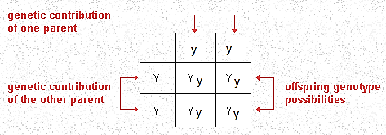
- Recessive: A phenotype or allele exhibited only when homozygous
The Punnett Square is a tool used to predict the genotypes and phenotypes of offspring. Punnett Squares have the parent gametes on the outside, and the products of fertilization are shown on the inside. This square only shows one trait, so it is for a monohybrid cross. These are probabilities, not guarantees.

Uncover Inheritance Based on Genotype and Phenotype Ratios
When solving genetics problems, it pays to know what patterns to look for. The parent genotypes and offspring phenotypic ratios in this table can help you figure out what kind of inheritance is at work.
Parent Genotypes | Offspring Phenotypic Ratio | Type of Inheritance
Aa x Aa | 3 A_ : 1 aa | Simple dominance, monohybrid cross
Aa x Aa | 1 AA : 2 Aa : 1 aa | Incomplete dominance
AaBb x AaBb | 9 A_B_ : 3 A_bb : 3 aaB_ : 1 aabb | Dihybrid cross
Genetics: Understanding Chromosome Disorders

CHROMOSOMAL ABNORMALITIES
Chromosomal abnormalities, in the form of nondisjunction, are very common among humans. It's estimated that up to half of all miscarriages are due to some form of chromosome disorder. Sex chromosome disorders are the most commonly observed type of aneuploidy in humans, because X-chromosome inactivation allows individuals with more than two X chromosomes to compensate for the extra "doses" and survive the condition.
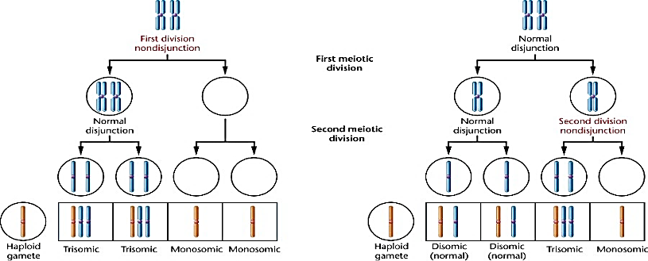
Nondisjunction occurs when chromosomes fail to separate evenly during either Meiosis I or Meiosis II. This results in the incorrect number of chromosomes being passed down to the offspring.

Three common categories of nondisjunction results crop up in humans:
- Monosomy: Occurs when one chromosome lacks its homolog. (EX Turner’s syndrome [45 X]
- Trisomy: Occurs when one extra copy of a chromosome is present. (EX: Trisomy 21—Down’s syndrome…3 copies of the 21st chromosome)(EX: Kleinfelters…3 copies of sex chromosomes [47 XXY]
- Polyploid: Occurs when an entire extra set of chromosomes is present. This is fatal in animals, but fine for plants (EX: Strawberries are Octoploid..they have 8 sets instead of 2)

Most chromosome conditions are referred to by category of aneuploidy followed by the number of the affected chromosome. For example, trisomy 13 means that three copies of chromosome 13 are present.

POINT ABNORMALITIES
Sometimes mutations occur on a much smaller scale that cause genetic disorders. Below is a list of genetic diseases. Autosomal diseases are not linked to a gender, they are on chromosomes 1-22. Sex-linked traits are found on the X chromosome and tend to be present more in males (who only have one X, so they cannot mask a negative recessive trait with a second X)
Disease | Type | Effects
Sickle-cell anemia | Autosomal recessive | Changes shape of RBS; not as good at picking up O₂
Color-blindness | Sex-linked | Difficulty discerning certain shades of color
Huntingdon’s disease | Autosomal dominant | Degrades nerve cells, leads to muscle and cognitive problems

DETECTING ABNORMALITIES
The use of pedigrees (left) and karyotypes (right) can be helpful in determining how a genetic disease is being passed down or if a person has a genetic disease.
