Mitosis and Meiosis Webquest Name: ________________________
Biology Date: ___________ Period: _______

Objective: In this activity, you will use the following web pages to examine the processes of mitosis and meiosis. Both of these processes are important in homeostasis as well as human reproduction.

PART A: Cell Growth and Mitosis
Please go to the following webpage: http://plaza.ufl.edu/alallen/pgl/modules/rio/stingarees/module/index.html

- What is the function of the cell membrane related cell division? _______________________________
- What is the role of the nucleus in cell division? ______________________________________
- What is the role of the centrioles in cell division? ______________________________________
- What is the role of the microtubules in cell division? ______________________________________

Click on the tab, “Why Must Cells Divide?”
- Why are cells limited in size? ___________________________________________________________
- Click on the animation. A cell with 2cm sides has what surface area? ______What volume? _________
- What would be the surface to volume ratio? _______________________________________________
- A cell with a large volume will have a more difficult time doing what? __________________________

Click on the tab, “What Does Mitosis Do?”
- What are the 2 major functions of mitosis? ________________________________________________

Click on the tab, “Built-in Controls in Mitosis”
- What are the 2 ways that cells “know” to stop dividing? ______________________________________

Please go to the following webpage: http://www.emc.maricopa.edu/faculty/farabee/BIOBK/BioBookmito.html

- What ends the cell division process where one cell splits from the sister cell? _____________________
- Some cells divide rapidly. Example? ______________
Some cells do not divide at all after maturity. Example? _______________________
- What is the result of binary fission (genetically the same or different)? _________________________
- What is the genetic relationship between resulting cells in mitosis (genetically the same or different)? _________________________________________________
- Label the following steps of mitosis:

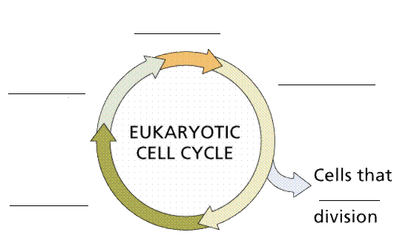

PART B: Meiosis
Please go to the following webpage: http://www.lewport.wnyric.org/jwanamaker/animations/meiosis.html or
http://www.cellsalive.com/meiosis.htm
- Why is the meiosis important? _____________________________________________________
- Start the animation. What do the chromosomes do in Prophase 1? ___________________________
- Compare how chromosomes line up on the equator (for separation) in Metaphase 1 and 2?
_________________________________________________________________________________
__________________________________________________________________________________
- In which phase are the number of chromosomes divided in half as a reduction division(Meiosis 1 or 2)? __________________

- Label the following steps of Meiosis: http://www.accessexcellence.org/RC/VL/GG/meiosis.html

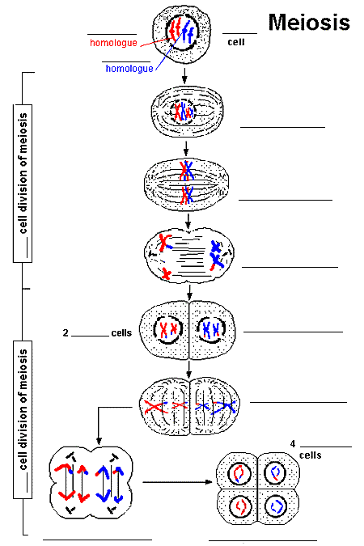

PART C: Comparing and Contrasting Mitosis and Meiosis
http://www.biology.arizona.edu/CELL_BIO/tutorials/meiosis/problems.html
http://www.cellsalive.com/meiosis.htm
http://www.stolaf.edu/people/giannini/flashanimat/celldivision/meiosis.swf
http://www.pbs.org/wgbh/nova/baby/divide.html#

After visiting the following web pages, compare and contrast mitosis and meiosis.

Then, fill in the following Venn Diagram of the terms listed below.

Terms:
Asexual reproduction Haploid
Sexual reproduction Diploid
Same Chromosome number Sex cells
Different Chromosome number somatic cells
One part to cell division cell division
Two parts to cell division (I and II) growth
Example: Bacteria reproduction repair
Example: Human reproduction
chromosomes

PART C: Comparing and Contrasting Mitosis and Meiosis

Mitosis Meiosis Does not belong:

